Machine Learning with Spark ML

Github link:- https://github.com/YashmanSingh2003/Banking_Distributed_ML_Project
Objective
Apply the concepts of Spark ML to build and evaluate a machine learning model using the bank.csv dataset. The goal is to predict whether a client will subscribe to a term deposit (binary classification).
- Data Loading and Initial Exploration:
  - Load the bank.csv dataset into a Spark DataFrame.
  - Perform basic exploratory data analysis (EDA) to understand the dataset. Display the schema and the first few rows.
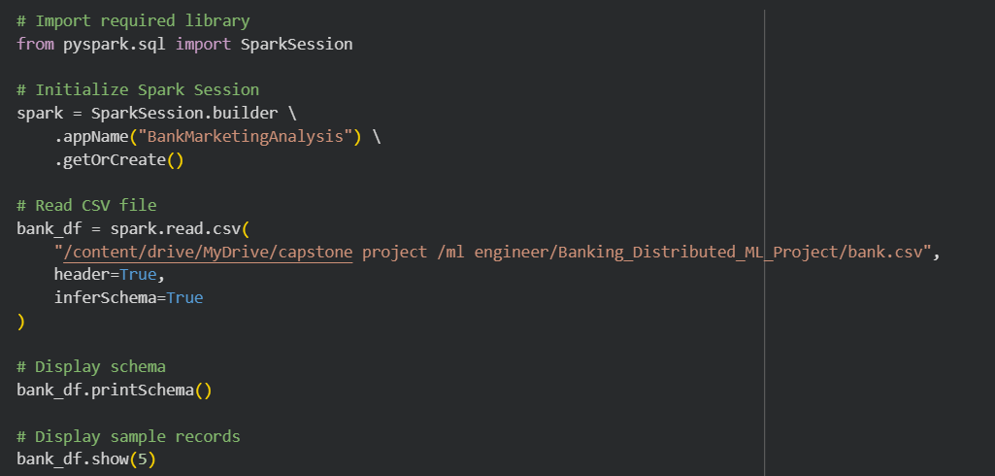
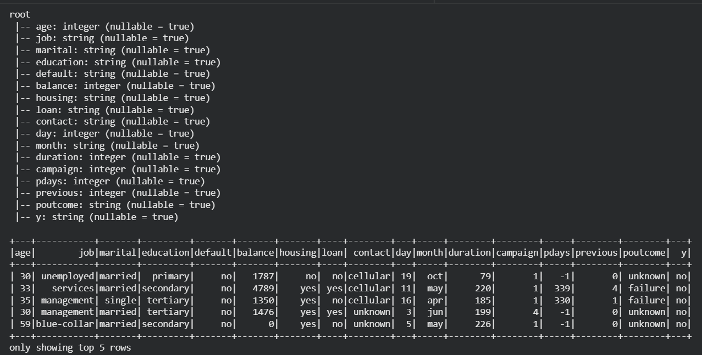
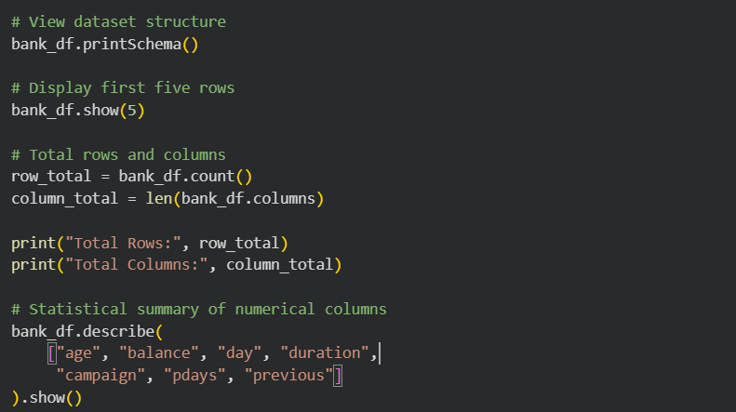
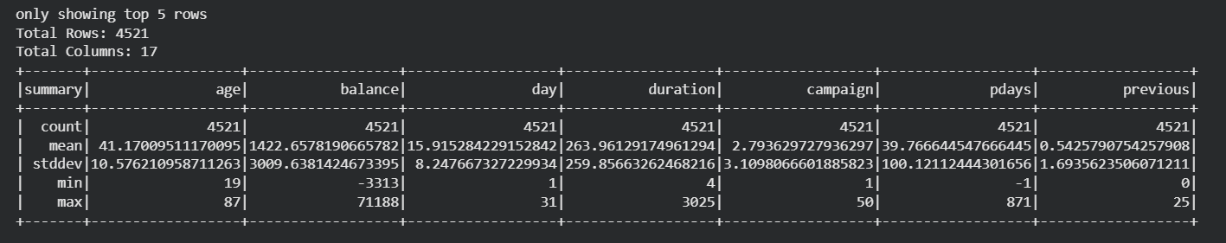

The dataset was loaded into a Spark DataFrame using SparkSession. Schema inference was enabled to automatically detect correct data types for each column.
Dataset contains 17 columns and 4521 records Includes numerical, categorical, and target variable (y) Data loaded successfully without null issues
2. Data Preprocessing:
- Handle missing values in the dataset.
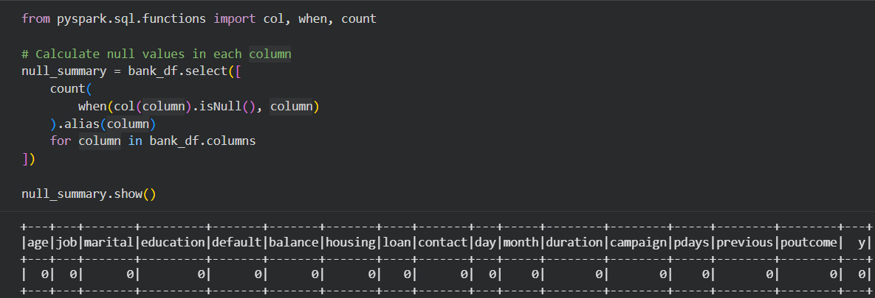
The dataset was examined for missing values across all columns. No null values were found, indicating that the dataset is complete and does not require any missing value treatment before model development.

- Handle Outliers in the dataset
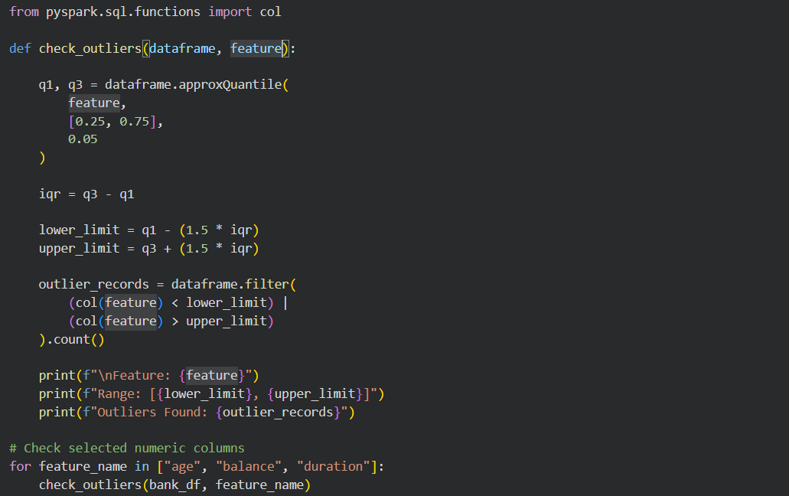
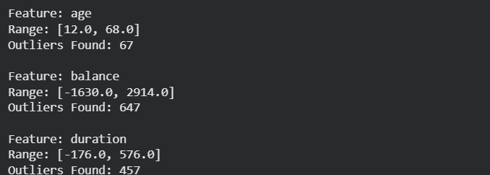
Outliers were identified in numerical attributes using the Interquartile Range (IQR) method. Features such as balance and duration contained a notable number of outliers. These values may represent genuine customer behavior and were retained for further analysis.

In "age" feature there are 67 outliers. In "blance" there are 647 outliers. In duration there are 457 outliers.

- Convert categorical variables to numerical format using StringIndexer or OneHotEncoder.
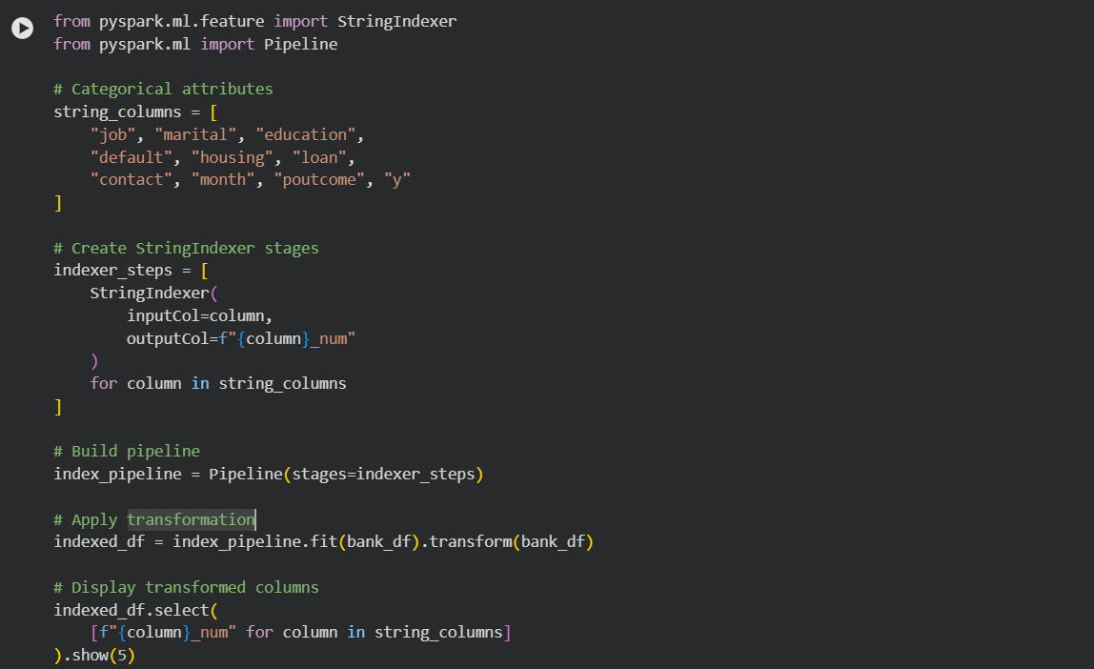
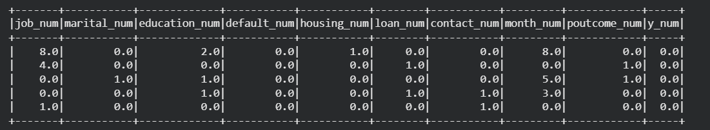
A VectorAssembler was used to combine all predictor variables into a single feature vector named features. This included both the numerical attributes and the indexed categorical variables generated during preprocessing.
The resulting features column contains all information required by machine learning algorithms in a compact vector format. The target variable y_indexed was retained separately as the label column. This step completed the feature engineering process and transformed the dataset into a structure that can be directly used for model training and evaluation in Spark ML.
3. Feature Engineering and Data Transformation:
  - Create a feature vector using VectorAssembler by combining all feature columns.
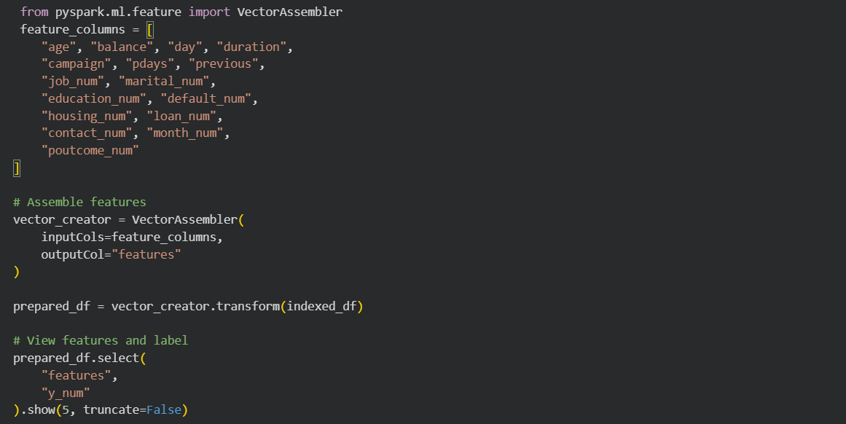
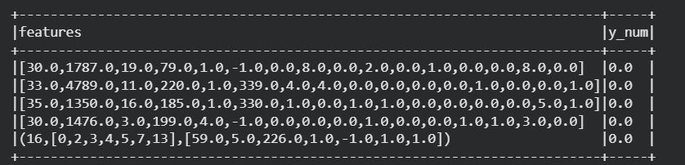
A VectorAssembler was used to combine all predictor variables into a single feature vector named features. This included both the numerical attributes and the indexed categorical variables generated during preprocessing.
The resulting features column contains all information required by machine learning algorithms in a compact vector format. The target variable y_indexed was retained separately as the label column. This step completed the feature engineering process and transformed the dataset into a structure that can be directly used for model training and evaluation in Spark ML.
4. Model Training and Selection:
- Choose a classification model (e.g., Logistic Regression, Decision Tree Classifier) for predicting the subscription to a term deposit.
- Split the data into training and test sets.
- Train the model on the training dataset.
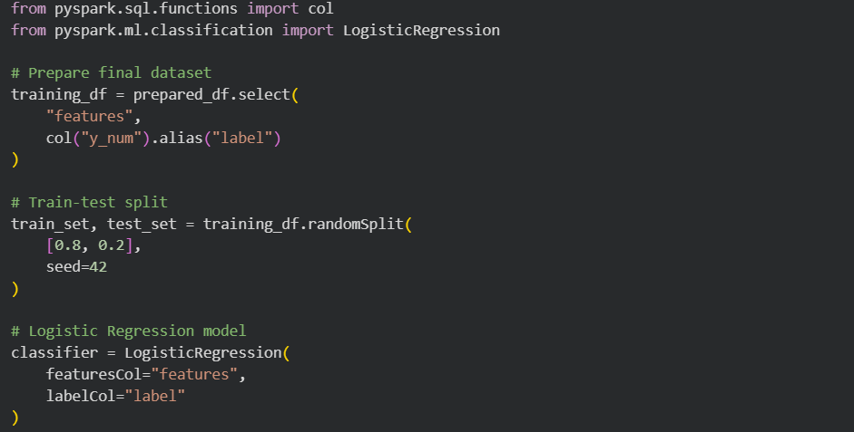
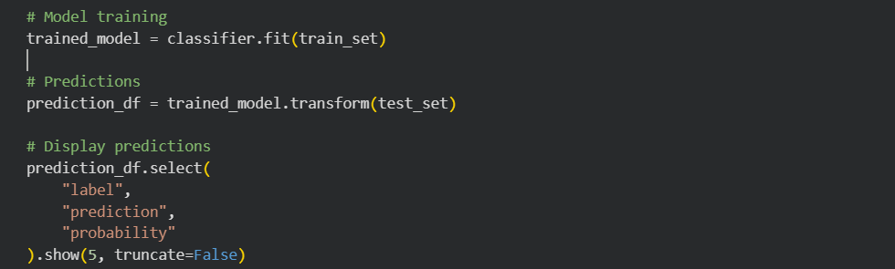
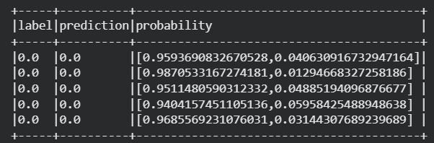
Logistic Regression was selected as the classification algorithm because the problem involves predicting a binary outcome (subscription: yes or no). The prepared dataset was divided into training and testing subsets using an 80:20 split ratio.
The model was trained using the training data and subsequently used to generate predictions on the test dataset. The prediction output included predicted class labels and probability scores, providing information about the model's confidence in each prediction. Logistic Regression is widely used for binary classification problems due to its simplicity, interpretability, and effectiveness, making it a suitable choice for this banking marketing dataset.
5. Model Evaluation:
- Evaluate the model on the test dataset using appropriate metrics.
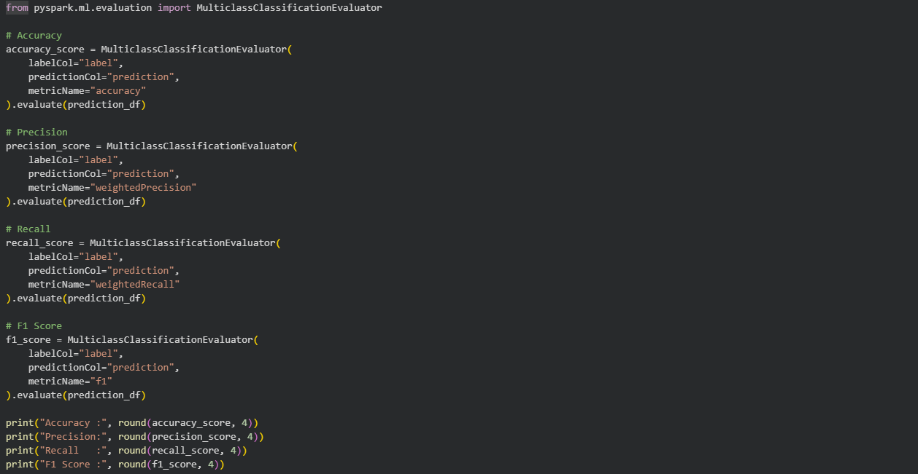
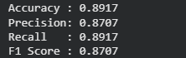
The performance of the Logistic Regression model was evaluated using Accuracy, Precision, Recall, and F1 Score. The model achieved an accuracy of 89.17%, indicating that nearly nine out of every ten predictions were correct.
The precision score of 87.07% demonstrates that the model is highly reliable when predicting customer subscriptions. The recall value of 89.17% indicates that the model successfully identified most of the actual subscription cases. The F1 score of 87.07% reflects a strong balance between precision and recall. Overall, these metrics indicate that the model performs effectively and can accurately predict customer responses to term deposit marketing campaigns.
6. Hyperparameter Tuning:
- Perform hyperparameter tuning (using ParamGridBuilder and CrossValidator.)
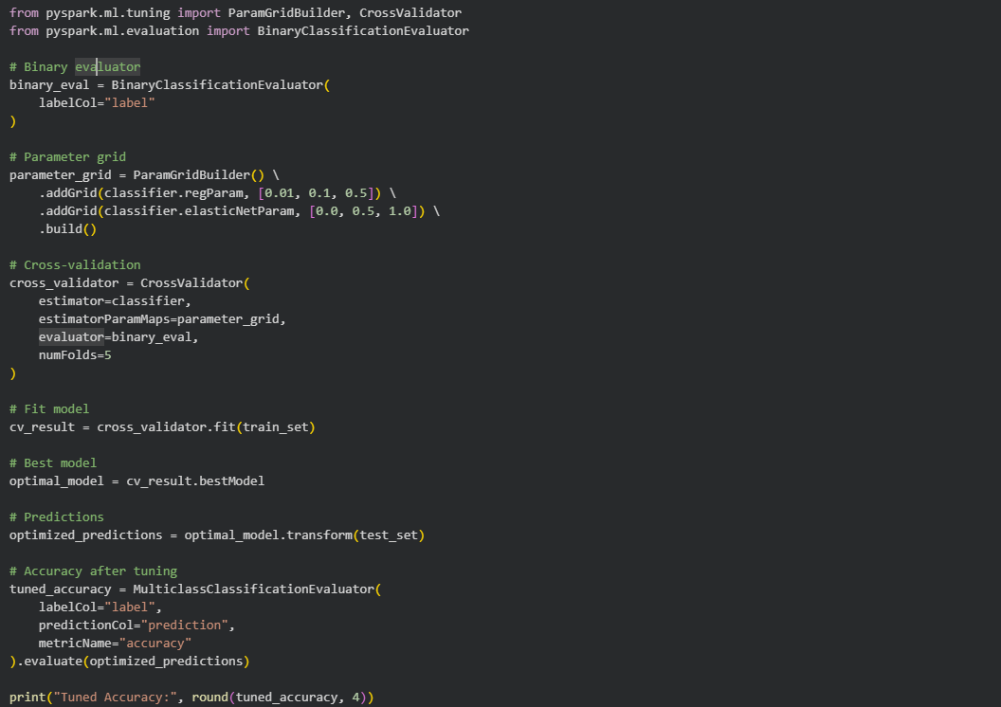
Hyperparameter tuning was performed using ParamGridBuilder and CrossValidator with five-fold cross-validation. Multiple combinations of regularization parameters and elastic net settings were tested to identify the optimal model configuration.
The best-performing model achieved an accuracy of 89.06%, which is very close to the original model's accuracy. This suggests that the baseline Logistic Regression model was already well-optimized. Cross-validation also confirmed the stability and consistency of the model across different training subsets. Hyperparameter tuning helped validate the robustness of the model and ensured that the selected configuration generalized well to unseen data.
7. Advanced Analysis:
- Analyze the feature importances (if applicable) or coefficients of the model to gain insights into which features are most influential in predicting the outcome.
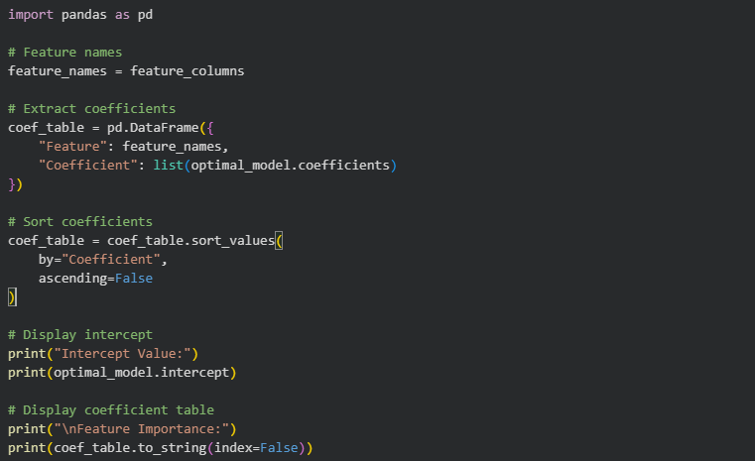
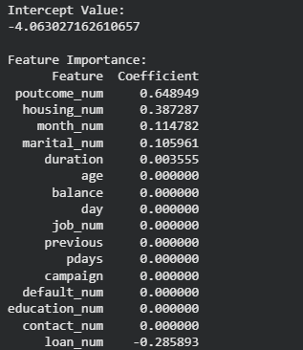
The coefficients of the Logistic Regression model were analyzed to determine which features had the greatest influence on customer subscription decisions. The previous campaign outcome (poutcome) had the strongest positive coefficient, indicating that customers who responded favorably in previous campaigns were more likely to subscribe again.
Housing loan status, marital status, and the month of contact also showed positive contributions toward predicting subscriptions. In contrast, personal loan status exhibited a negative coefficient, suggesting that customers with personal loans were less likely to subscribe to a term deposit. Several variables such as age, balance, and education had relatively small coefficients, indicating a lower impact on the prediction process. This analysis provides valuable business insights into the factors that influence customer behavior and subscription decisions.

Overall Conclusion:
The Bank Marketing dataset was successfully analyzed and processed using Apache Spark MLlib. The project involved data loading, exploratory data analysis, missing value detection, outlier analysis, categorical variable transformation, feature engineering, model training, hyperparameter optimization, and feature importance analysis.
A Logistic Regression classifier was developed to predict whether a customer would subscribe to a term deposit. The model achieved approximately 89% accuracy along with strong precision, recall, and F1-score values, demonstrating excellent predictive capability. Furthermore, feature coefficient analysis identified previous campaign outcomes, housing loan status, and personal loan status as important factors influencing customer decisions.
Overall, the project demonstrates the effectiveness of Apache Spark for large-scale data preprocessing, machine learning, and predictive analytics in banking and marketing applications.

Colab Link :- https://colab.research.google.com/drive/1aR1k2_EGlMMDn_MibFxb6ceTGH6Wv6md?usp=sharing

